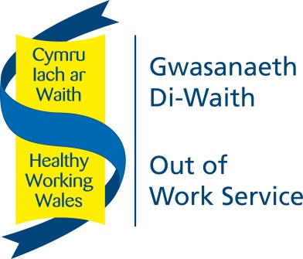

**Out of Work Peer Mentoring Service (OoWS)**

**OFFICIAL-SENSITIVE**

**Version 4.1 – February 2018**

|  |  |  |  |  |  |  |
| --- | --- | --- | --- | --- | --- | --- |
| **REFERRAL INTO THE OUT-OF-WORK PEER MENTORING SERVICE** | | | | | | |
| **Participant Details** | | | | | | |
| Participant Name: |  | | | | | |
| Participant NI Number: |  | | | | | |
| Participant DOB: | __/__/__   * 16-24 * Over 25 | | | | | |
| Participant Address: |  | | | | | |
| Participant Contact Details: | **Tel:**  **Email:** | | | | | |
| Current Employment Status: | **Economically inactive** |  | **NEET 16-24** |  | **Long-term unemployed**  Receiving JSA support for 12 months plus |  |
| **Reason for referral / areas to note:** | | | | | | |
|  | | | | | | |
| **Referred by:** | | | | | | |
| Name of Referrer: |  | | | | | |
| Job Title / Organisation: |  | | | | | |
| Contact Details: | Address:  Tel:  Email: | | | | | |

Disclaimer:

I confirm there is no conflict of interest and the above information is correct to the best of my knowledge

|  |  |
| --- | --- |
| **Signature of Referrer:** |  |
| **Date:** |  |

**Please send completed referral forms to:**[**ask@cyflecymru.com**](mailto:ask@cyflecymru.com) **/ 0300 777 2256**